Jonathan Chen

Econ 581D

Data Exercise Paper

**Research Question**: Given the evolution of the NBA, do modern NBA players receive a greater return in the labor market based on individual production or contribution to team production? How does their marginal return from 2019-2020 compare to that of 2020-2021?

**Introduction**:

In the labor market, workers are expected to be paid the value of their marginal product of labor. However, in industries where contribution to team productivity is necessary and pivotal to the success of both the team and the individual, it can be difficult to reward workers based on their marginal product of labor. By studying the NBA, a market where the productivity, accolades and monetary rewards of the workers are documented and widely available, we hope to discover whether workers are properly compensated based on their individual and collective contributions. Arcidiacono (2014) studied returns in the labor markets based on spillover effects and concluded that players are poorly compensated based on their team contributions. While Arcidiacono thoroughly analyzed data from 2006-2010, Arcidiacono’s method of analyzing production on a per possession basis may not be ideal for returns in this specific labor market. Arcidiacono chose to separate player output into three categories, and forgo defensive spillovers. This is a significant lack of data, as players spend as much time playing offense as they do defense and it is extremely correlated with team success. Arcidiacono’s decision will have skewed his findings. Given this situation, this paper will attempt to answer whether players are properly compensated based on their contribution to team production, considering both offensive and defensive production and how this value compares to returns based on individual production.

**Data**:

Player data utilized towards this research was obtained from basketball-reference.com. The individual’s statistics were supplemented by their corresponding value of marginal product of labor, their contracts, obtained by sportrac.com.

We obtained player’s position, age, team, games played, games started, minutes played, field goal, field goal attempts, field goal percentage, three pointers made per game, three pointers attempted, three point percentage, two pointers made, two pointers attempted, two point percentage, effective field goal, free throws attempted, free throws made, offensive rebounds, defensive rebounds, true rebounding, assists, steals, blocks, turnovers, personal fouls, and points from basketball-reference.com.

We created a new variable, True Defensive Impact (TDEF), in order to properly measure defensive capability through measuring defensive spillover effects. Given the differing types of defensive roles that the modern NBA requires, smaller players are able to become less of a defensive liability. Similarly, this allows bigger players to play differently, and have impacts in nontraditional areas. TDEF properly measures a player’s defensive spillover by weighting their defensive statistics against their role, and overvalues the aspects of defense that the player exceeds expectations in.

This dataset is able to answer my question because it is a good indicator of the NBA population. There are 58 individuals, with a median age of 25.93. That is close to the median age of the NBA population, 25.76. The median sample of games played is 42.76 compared to the population median of 38.22. The median of minutes played is 22.73 compared to the population median of 20.54. 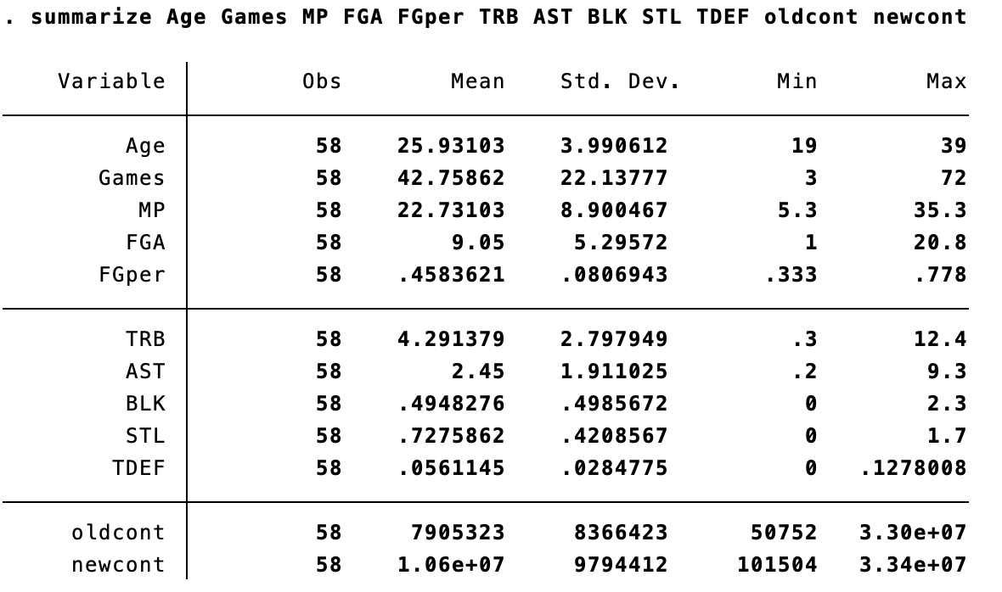

**Empirical specifications**:

The simplest OLS regression will involve us regressing all of the dependent variables listed above (age, games played, minutes, TRB, Assists, blocks, steals) against the independent variable, contract size. This regression will have significant endogeneity concerns, since a lot of these variables are correlated with one another. We risk having issues of multicollinearity with the dependent variables in this regression. There are also certainly variables that are omitted, that can explain true offensive, defensive impacts better that the ones that we have obtained, but given that a lot of these variables are biased towards certain positional needs or team constructions, it is best if we focused on player statistics. I choose to have two regressions, to examine if the value of marginal product of labor was properly rewarded over time.

In order to attempt to minimize multicollinearity, I selected variables that will have minimum correlation with one another. The variables in my regressions are points scored, assists, TDEF (true defensive impact) and minutes played. Players who were missing contract values for either the 2019-2020 season or 2020-2021 season were not considered in order to account for player fixed effects. Players who were traded within the same season were not considered for regression to account for team fixed effects.

* ${Contract}_{2019-2020}=β_{0}+β_{1}PTS+β_{2}AST+β_{3}TDEF+β_{4}MP$ 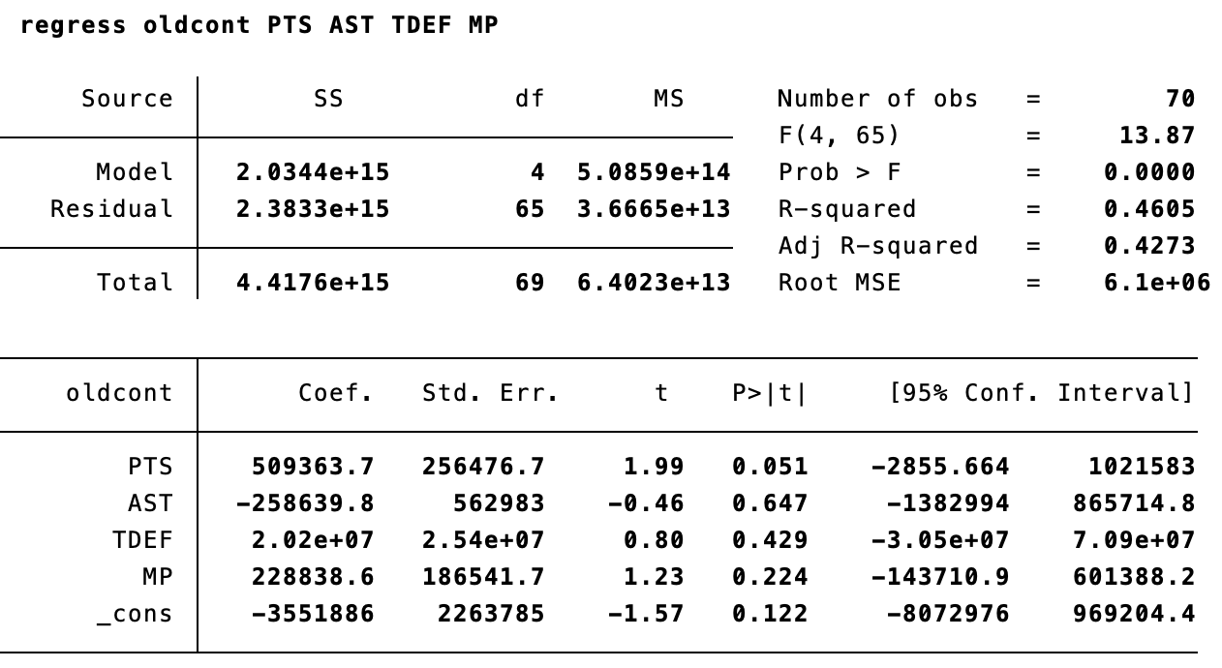
* ${Contract}_{2020-2021}=β_{0}+β_{1}PTS+β_{2}AST+β_{3}TDEF+β_{4}MP$ 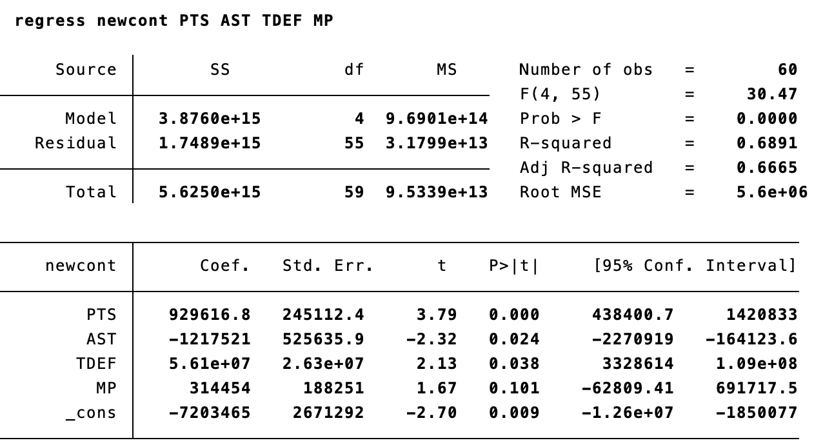

Scatter plot depicting a linear regression between True Defensive Impact and the corresponding player’s contract from the 2019-2020 NBA season. As we can see, players are poorly rewarded for their defensive spillover effects, with excellent defenders not being properly compensated. 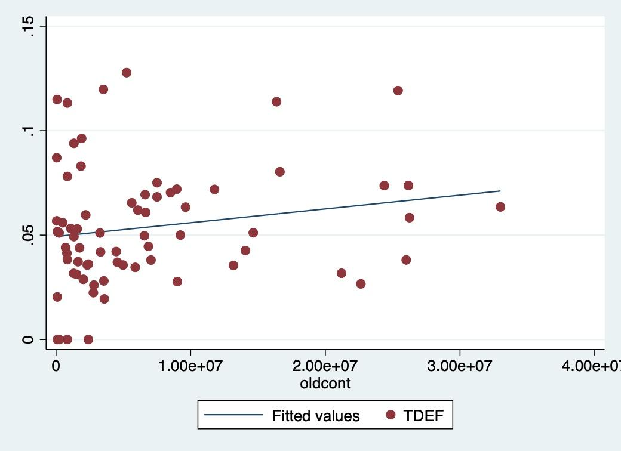

Scatter plot depicting a linear regression between True Defensive Impact and the corresponding player’s contract from the 2020-2021 NBA season. Players are now being more properly compensated for higher defensive impact. 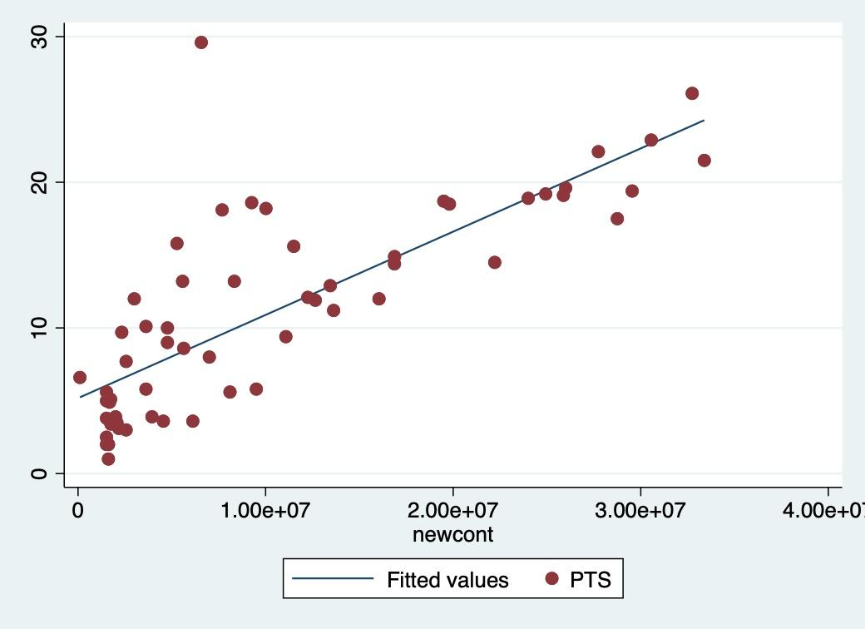

**Conclusion**:

NBA players receive a greater return in the labor market based on individual production, as seen in PTS, in both contract years. It also appears as if current NBA contracts reward NBA productivity better compared to NBA contracts from the prior season. While contribution to team production in assists as seen in the tables, is still not properly measured, contributions to team production with defensive spillover effects were rewarded significantly more. This is understandable as one player’s excellence in defense can often cover another player’s weaknesses. This indicates progress with returns to marginal product of labor valuation and that the current metrics are more capable of measuring the changing landscape of the NBA.

**Potential shortcomings and solutions:**

While I was better able to account for defensive spillover effects, it came to my knowledge during my research that not all of the contracts analyzed in this sample were recently signed contracts. This means that the valuation of some player’s marginal product of labor was not determined by their success in the prior season, but rather a previous contract, signed with belief stemming from an overvaluation of that player’s future ability or likeliness that the coach or front office believed in. This means that valuation can be a very emotional manner, and that the NBA market may in fact not be a proper representation of studying spillover effects. There are also likely variables that may have been more suited for the regression in this paper, but I was unsure of how to include them given their overwhelming correlation with one another.

Despite this, a lot of industries in the world now operate on a contract basis in industries such as schools with fixed term tenure contracts, offices with contractual positions that must be filled for a fixed period of time, model contracts, etc. A contract often treats the employee as a prospect, with hopes that such prospect can bloom and provide value about that of their now undervalued contract. We can study similar effects of this in the NBA with rookie contracts, such as that of Luka Doncic. Doncic is regarded as one of the best players of the game and his contract is extremely undervalued given his production, with him receiving $8 million dollars when it is believed he can fetch over $35 million in the market, provided he was contract free. As his career progresses and we understand how some variables interact with others, it may be possible to measure future prospects better and reward them with their deserved marginal product of labor.